2400040454
Harsha Vardhan.

EXP 5- Webpage Development with HTML attributes

1.1 AIM: - To develop webpage with HTML attributes.

1.2 Objectives: To understand concept of Design of simple web page with HTML

1.3 Apparatus: Desktop or Laptop with any operating system like UNIX, LINUX and Windows.

1.4 Software: Notepad or Notepad++ or Visual Studio Code and any web Browser like Internet Explorer, Google Chrome, and Mozilla Firefox etc.

PRE-LAB

1.Draw the outline of a webpage.
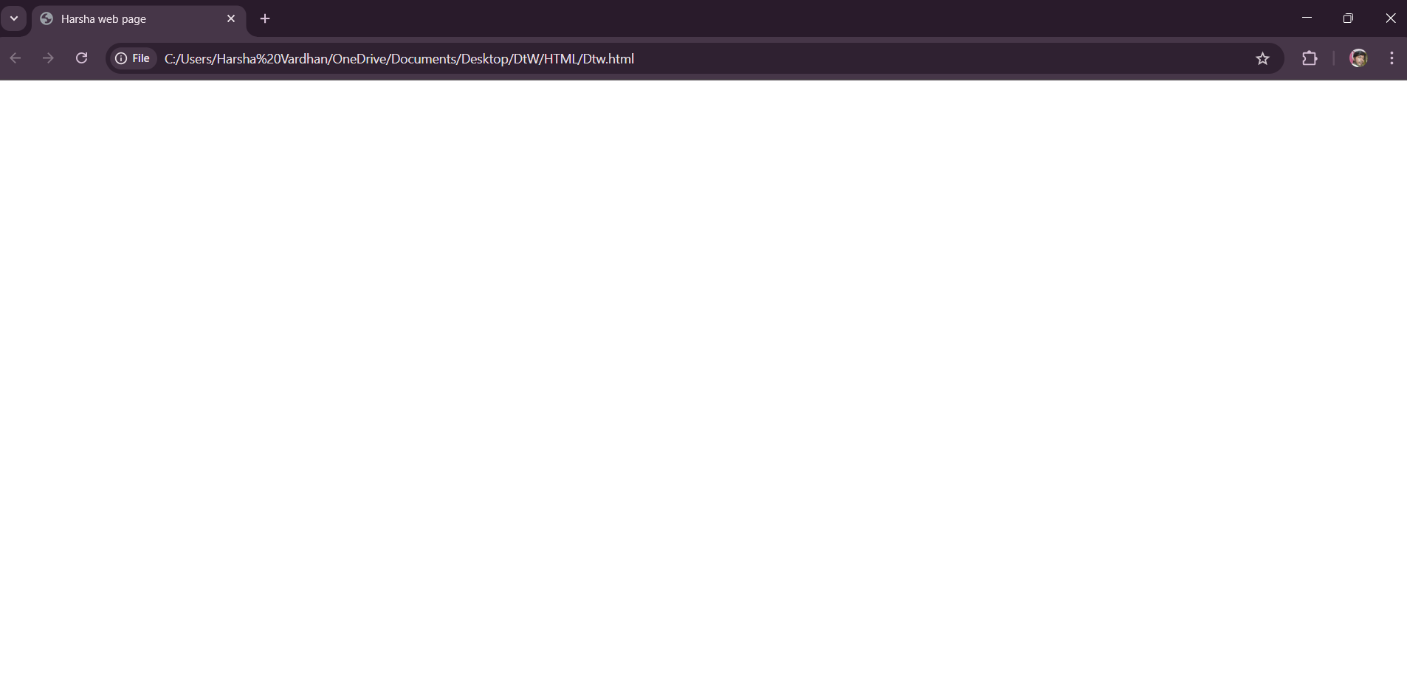
2.Draw the outline of website.
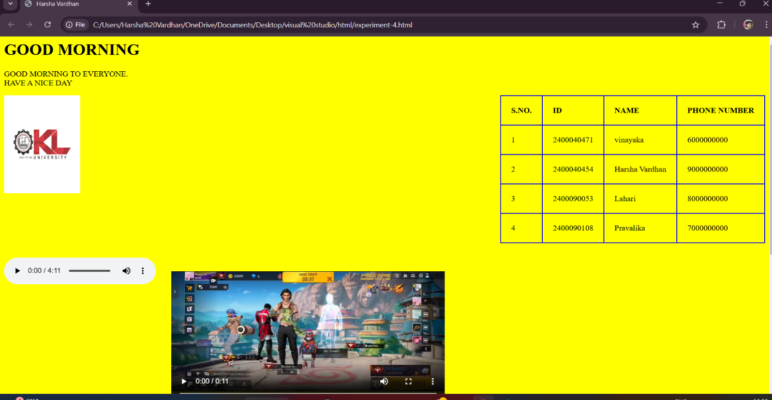

1.5 Procedure (CODE):

<html>
<head>
<title>Harsha web page </title>
<style>
table, th, td {
border: 1px solid blue;
border-collapse: collapse;
padding: 15px;
text-align: left;
}
body {
color: red;
background-color: yellow;
}

img {
float: left;
margin-right: 20px;
}
table {
width: 60%;
}
</style>
</head>
<body>
<h1> GOOD MORNING </h1>
<p> This is DTW group information<br> Have a nice day </p>
<img src="kl.html.jpg" alt="kl.html" width="100" height="100">

<table>
<tr>
<th> S.NO. </th>
<th> ID </th>
<th> NAME </th>
<th> Phone no:</th>
</tr>
<tr>
<td> 1 </td>
<td> 2400040471 </td>
<td> Vinayaka </td>
<td> 900000023</td>
</tr>
<tr>
<td> 2 </td>
<td> 2400040454 </td>
<td> Harsha </td>
<td> 9000050000</td>
</tr>
<tr>
<td> 3 </td>
<td> 2400090053 </td>
<td> Lahari </td>
<td> 8000000000</td>
</tr>
<tr>
<td> 4 </td>
<td> 2400090108 </td>
<td> Pravallika </td>
<td> 7000000000</td>
</tr>
</table>

<ol>
<li> ECE </li>
<li> ECE </li>
<li> CS/IT </li>
<li> CS/IT </li>
</ol>

</body>
</html>

\\\\THE END////

